**EXPLORE THE WORLD WITH**

**SHEAFE’S FLAT BLUEBIRD**

STUDENT NAME: ___________________________________________ ROOM _____________

G’day Mate! Welcome to Australia, also known as “The Land Down Under.”

Australia today is a vibrant multicultural country with people of British descent, as well as Aboriginal and immigrants from many countries in Europe, Africa and Asia.

It is the sixth largest country in the world and the only country that is also a continent. Australia is in the Southern Hemisphere, where summer is from December to February.

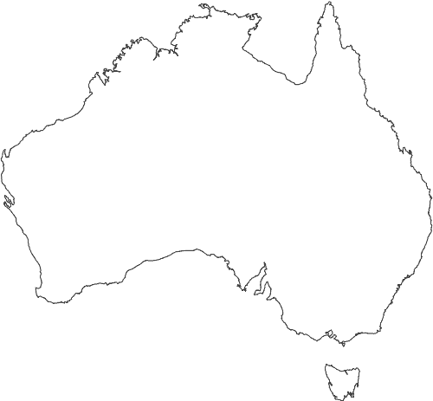

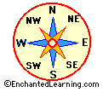

One of the Seven Natural Wonders of the World, the Great Barrier Reef, is located on the Eastern shore of Australia. The following are some interesting facts about the Reef:

* The Great Barrier Reef is the world's largest reef system
* The Great Barrier Reef is composed of over 2,900 individual reef
* The Great Barrier Reef has over 900 islands stretching for over 2,600 kilometers
* The Great Barrier Reef can be seen from outer space
* Tourism to the reef generates approximately AU$ 4-5 billion per year (Australian money)
* Thirty species of whales, dolphins, and porpoises have been recorded in the Great Barrier Reef
* Six species of sea turtles come to the reef to breed
* 215 species of birds (including 22 species of seabirds and 32 species of shorebirds) visit the reef or nest or roost on the islands
* Seventeen species of sea snake live on the Great Barrier Reef
* More than 1,500 fish species live on the reef
* There are at least 330 species of ascidians on the reef system

Answer the following questions using the information provided.

1. On the map on the front of this paper, label the shoreline where the Great Barrier Reef can be found.
2. In the space below, draw one of the animals that can be found at the Reef.

For those of you who would like more of a challenge:

1. On the map on the front of this paper, identify the following:
   1. Color and label the 6 States and label the 2 territories that that make up Australia.
   2. Which state is the Great Barrier Reef located next to?